**Data Analyst Bank Loan Project**

**First Page of dashboard**

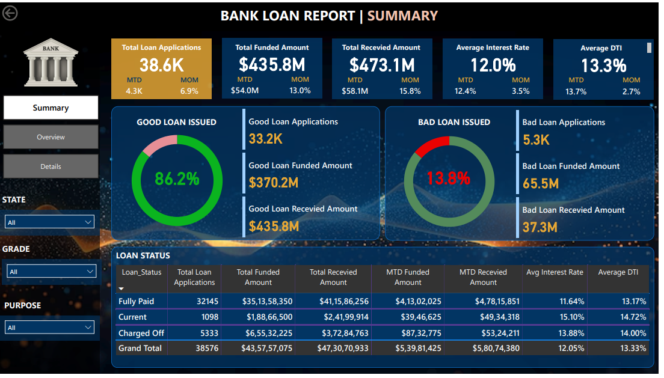

**Second Page of Deshboard**

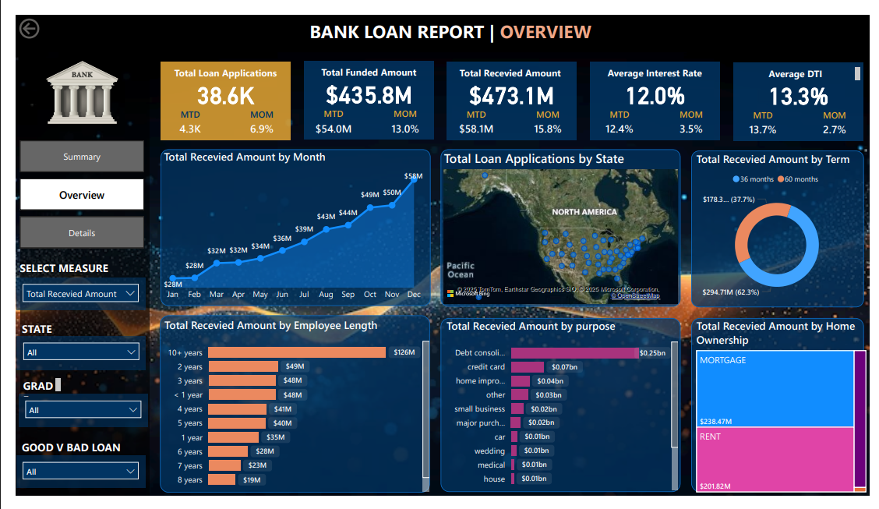

**Third Page of Deshboard**

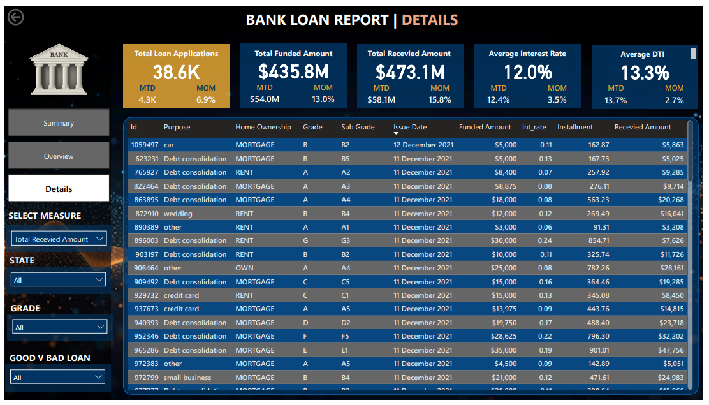

**PROBLUM STATEMENT**

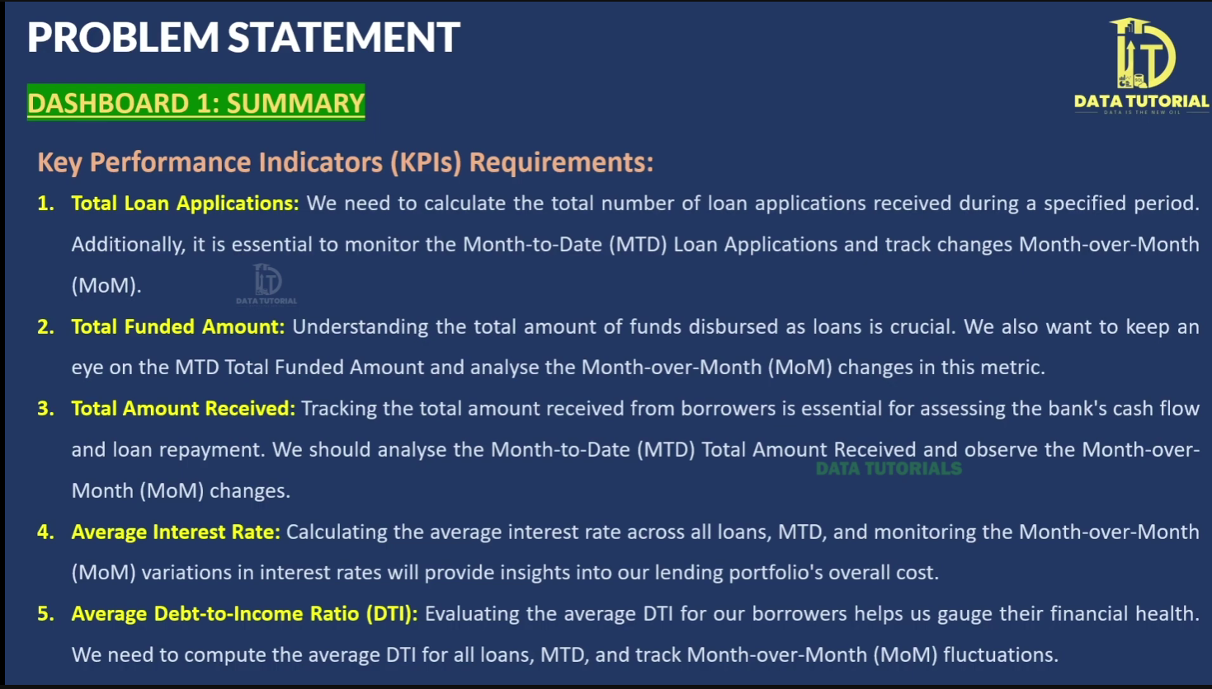

**Good Loan VS Bad Loan KPI**

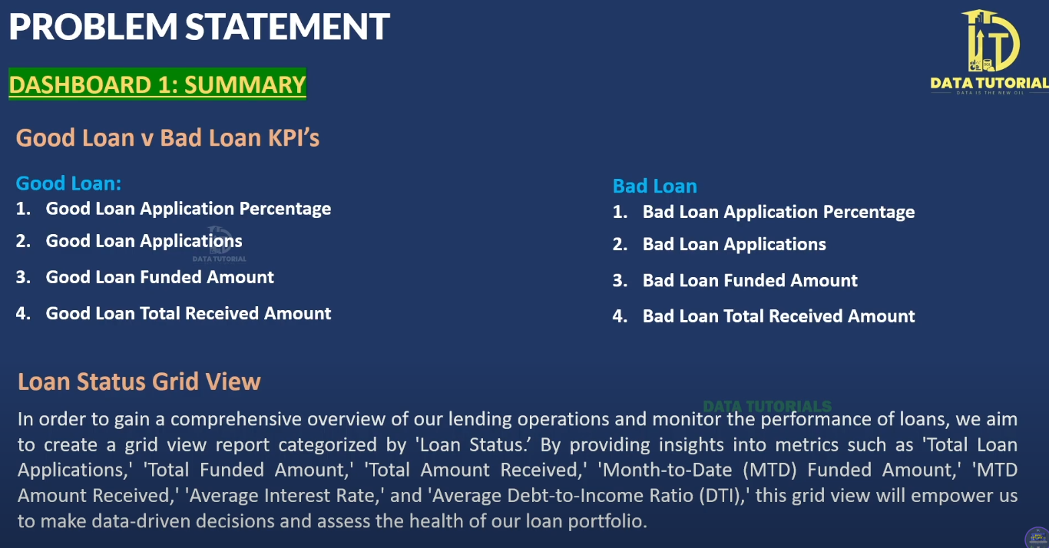

**DESHBOARD 2**

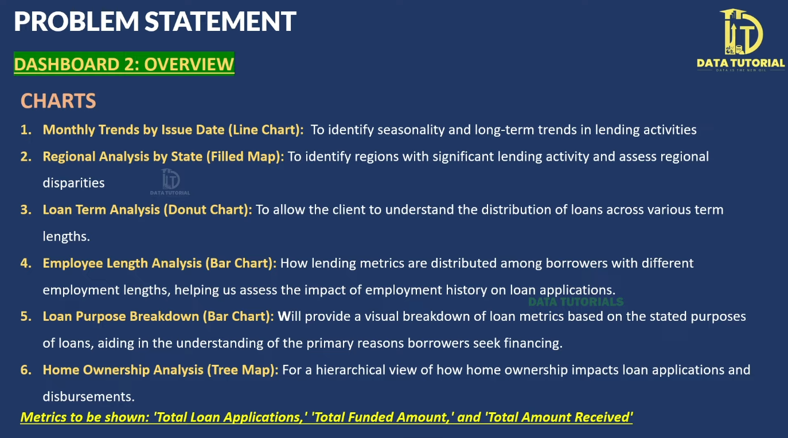

**DESHBOARD 3**

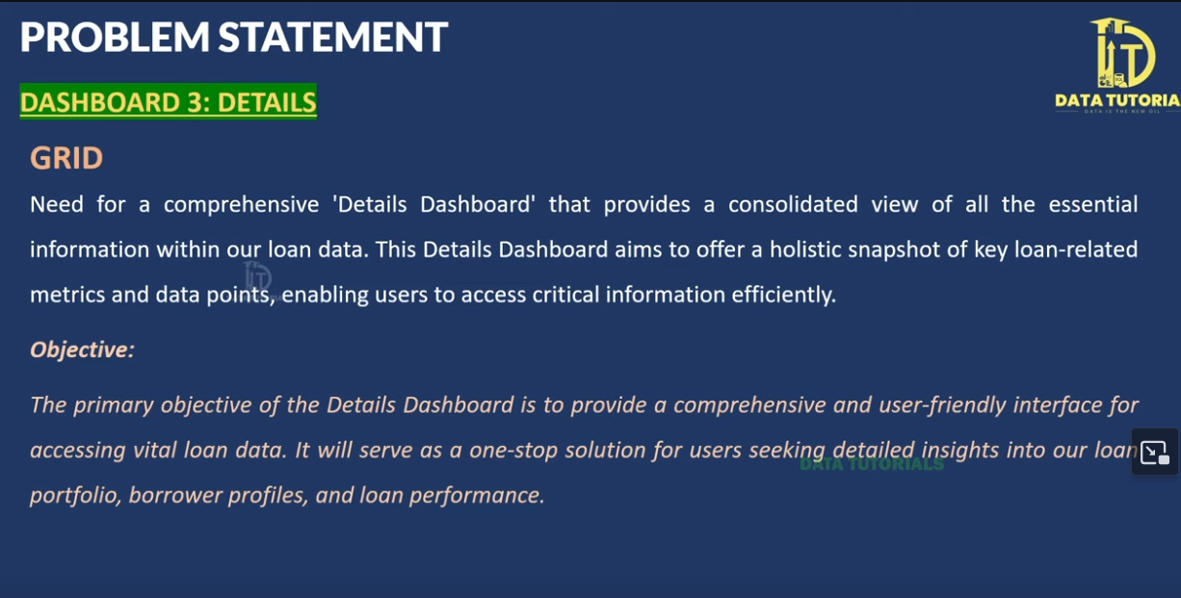

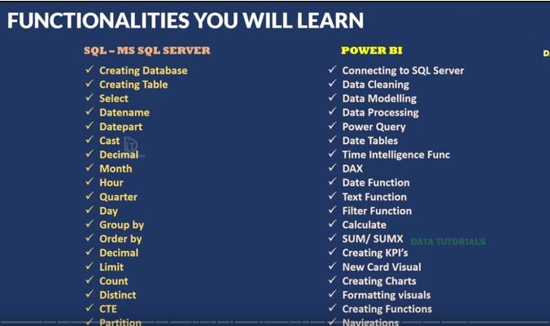

Bank Domain Knowledge

Here’s a **simple explanation** of the **Bank Loan Report – Domain Knowledge** so you can understand it easily:

**📌 What is a Bank Loan?**

A **bank loan** is money that people or businesses borrow from the bank and agree to pay back with **interest** (extra money as a fee for borrowing).

**📋 How Do Banks Collect Loan Information?**

Banks get data (information) from different places when someone applies for a loan:

1. **Loan Application**: The borrower fills a form with their personal and financial details.
2. **Credit Reports**: Banks check your credit history (how well you paid past loans) from credit bureaus.
3. **Bank’s Own Records**: Banks store data on past and current loans (how much was given, how much is paid back).
4. **Online Platforms**: If you apply or pay online, the data is saved.
5. **Third-party Sources**: Banks may use other companies to check your income or job.

**🏦 Steps Banks Follow to Approve a Loan**

1. **Loan Application**: You submit a form (online or offline).
2. **Document Review**: Bank checks your ID, income, credit score, etc.
3. **Identity Check**: To make sure you are who you say you are.
4. **Credit Check**: They look at your credit history to see if you pay debts on time.
5. **Income Check**: They verify your income to ensure you can pay the loan.
6. **DTI (Debt-to-Income Ratio)**: They compare your monthly debt to your income. Lower = better.
7. **Employment Check**: They may contact your employer to confirm your job.
8. **Collateral Check** (if needed): If the loan needs a guarantee (like a house or car), they assess its value.
9. **Risk Check**: They evaluate how risky it is to give you a loan.
10. **Approval/Denial**: Based on all this, they decide to give or deny the loan.
11. **Loan Agreement**: If approved, you sign a document with all terms and conditions.
12. **Disbursement**: The bank gives you the loan amount.
13. **Repayment**: You start paying back monthly with interest.
14. **Monitoring**: The bank keeps checking your payments and loan status.

**📊 Why Do Banks Analyse Loan Data?**

1. **Risk Assessment**: To decide if lending to you is risky or safe.
2. **Better Decision-making**: Helps decide whether to approve a loan.
3. **Loan Management**: Helps track all loans and detect problem areas.
4. **Fraud Detection**: To catch fake or suspicious loan applications.
5. **Regulation Compliance**: Banks must follow rules (like KYC and HMDA), so they need data for reporting.
6. **Customer Insights**: Understand customer needs and improve services.
7. **Profitability**: Check if loans are bringing profits or losses.
8. **Market Research**: Understand trends, customer needs, and competition.
9. **Credit Risk Management**: Helps control how much risk the bank is taking.
10. **Customer Retention**: Helps banks offer better options to keep customers happy and loyal.

**✅ In Simple Words:**

* **Banks collect, review, and analyze data** to decide who to lend money to and under what terms.
* **They use this data** to reduce risk, make good decisions, detect fraud, and serve customers better.

Let me know if you want a diagram or flowchart for this!

**BANK LOAN REPORT QUERY DOCUMENTS**

1. **BANK LOAN REPORT | SUMMERY**

**KPI’s:**

1. **Total Loan Applications**

SELECT COUNT(id) AS Total_Applications FROM bank_loan_data;

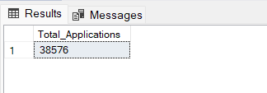

**\* MTD Loan Applications**

SELECT COUNT(id) AS MTD_Total_Applications FROM bank_loan_data

WHERE MONTH(issue_date) = 12 AND YEAR(issue_date) = 2021;

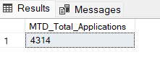

**\*PMTD Loan Applications**

SELECT COUNT(id) AS PMTD_Total_Applications FROM bank_loan_data

WHERE MONTH(issue_date) = 11 AND YEAR(issue_date) = 2021;

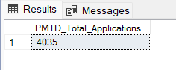

1. T**otal Funded Amount**

SELECT SUM(loan_amount) AS Total_Funded_Amout FROM bank_loan_data

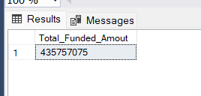

**\*MTD FUNDED AMOUNT**

SELECT SUM(loan_amount) AS MTD_Total_Funded_Amout FROM bank_loan_data

WHERE MONTH(issue_date) = 12 AND YEAR(issue_date) = 2021;

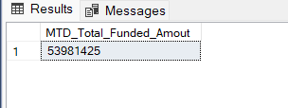

**\*PMTD FUNDED AMOUNT**

SELECT SUM(loan_amount) AS PMTD_Total_Funded_Amout FROM bank_loan_data

WHERE MONTH(issue_date) = 11 AND YEAR(issue_date) = 2021;

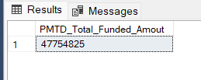

1. **TOTAL AMOUNT RECEVIED**

SELECT SUM(total_payment) AS Total_Amount_Recevied FROM bank_loan_data

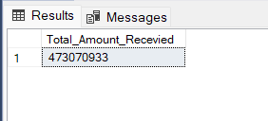

**\*MTD TOTAL AMOUNT RECEVIED**

SELECT SUM(total_payment) AS MTD_Total_Amount_Recevied FROM bank_loan_data

WHERE MONTH(issue_date) = 12 AND YEAR(issue_date) = 2021;

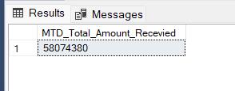

**\*PMTD TOTAL AMOUNT RECEVIED**

SELECT SUM(total_payment) AS PMTD_Total_Amount_Recevied FROM bank_loan_data

WHERE MONTH(issue_date) = 11 AND YEAR(issue_date) = 2021;

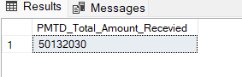

1. **AVERAGE INTEREST RATE**

SELECT ROUND(AVG(int_rate),4) * 100 AS AVERAGE_INTEREST_RATE FROM bank_loan_data;

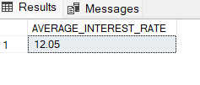

**\*MTD AVERAGE INTEREST RATE**

SELECT ROUND(AVG(int_rate),4) * 100 AS MTD_AVERAGE_INTEREST_RATE FROM bank_loan_data

WHERE MONTH(issue_date) = 12 AND YEAR(issue_date) = 2021;

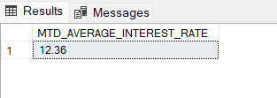

**\*PMTD AVERAGE INTEREST RATE**

SELECT ROUND(AVG(int_rate),4) * 100 AS PMTD_AVERAGE_INTEREST_RATE FROM bank_loan_data

WHERE MONTH(issue_date) = 11 AND YEAR(issue_date) = 2021;

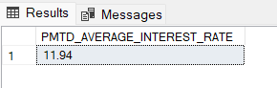

1. **AVERAGE DEPT_TO_INCOME_RATION DTI**

SELECT ROUND(AVG(dti),4) * 100 AS AVG_DTI FROM bank_loan_data;

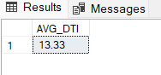

**\*MTD AVERAGE DEPT_TO_INCOME_RATION DTI**

SELECT ROUND(AVG(dti),4) * 100 AS MTD_AVG_DTI FROM bank_loan_data

WHERE MONTH(issue_date) = 12 AND YEAR(issue_date) = 2021;

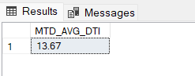

**\*PMTD AVERAGE DEPT_TO_INCOME_RATION DTI**

SELECT ROUND(AVG(dti),4) * 100 AS PMTD_AVG_DTI FROM bank_loan_data

WHERE MONTH(issue_date) = 11 AND YEAR(issue_date) = 2021;

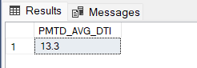

**GOOD LOAN & BAD LOAN KPI’s**

**1.Good Loan KPI’s**

1**.Good Loan Application Percentage**

SELECT

(COUNT (CASE WHEN loan_status = 'Fully Paid' OR loan_status = 'Current' THEN id END ) * 100)

/

COUNT(id) AS GOOD_LOAN_PERCENTAGE

FROM bank_loan_data;

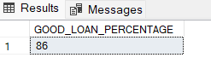

**2.Good Loan Applications**

SELECT COUNT(id) AS Good_loan_Applications FROM bank_loan_data

WHERE loan_status = 'Fully Paid' OR loan_status = 'Current' ;

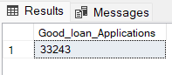

**3.Good Loan Funded Amount**

SELECT SUM(loan_amount) AS Good_loan_Funded_Amount FROM bank_loan_data

WHERE loan_status = 'Fully Paid' OR loan_status = 'Current';

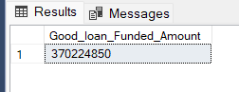

**4.Good Loan Total Received Amount**

SELECT SUM(total_payment) AS Good_loan_Received_Amount FROM bank_loan_data

WHERE loan_status = 'Fully Paid' OR loan_status = 'Current';

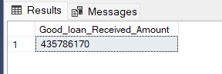

**2.Bad Loan KPI’s**

1**.Bad Loan Application Percentage**

SELECT COUNT(CASE WHEN loan_status = 'Charged Off' THEN id END)*100

/COUNT(id) AS BAD_LOAN_PERCENTAGE

FROM bank_loan_data

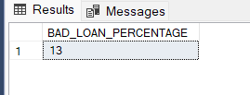

**2.Bad Loan Applications**

SELECT COUNT(id) AS Bad_Loan_Application

FROM bank_loan_data

WHERE loan_status = 'Charged Off';

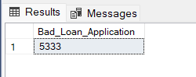

**3.Bad Loan Funded Amount**

SELECT SUM(loan_amount) AS Bad_Loan_Funded_Amount

FROM bank_loan_data

WHERE loan_status = 'Charged Off'

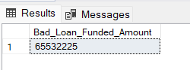

**4.Bad Loan Total Received Amount**

SELECT SUM(total_payment) AS Bad_Loan_Total_Received_Amount

FROM bank_loan_data

WHERE loan_status = 'Charged Off';

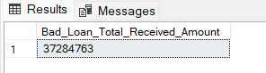

**LOAN STATUS**

SELECT loan_status ,

COUNT(id) AS Total_Loan_Application ,

SUM(loan_amount) AS Total_Funded_Amount,

SUM(total_payment) AS Total_Amount_Recevied,

ROUND(AVG(int_rate * 100),2) AS Interest_Rate,

ROUND(AVG(dti * 100),2) AS DTI

FROM

bank_loan_data

Group BY

loan_status;

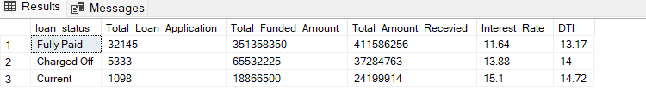

**MONTH TO DATE FUNDED AND RECEVIED AMOUNT**

SELECT loan_status,

SUM(loan_amount) AS MTD_Funded_Amount,

SUM(total_payment) AS MTD_Total_Amount_Recevied

FROM bank_loan_data

WHERE MONTH(issue_date) = 12

GROUP BY loan_status

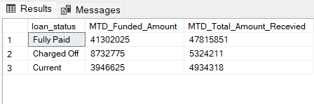

1. **BANK LOAN REPORT | OVERVIEW**

**1.Monthly Trends by Issue Date**

SELECT

MONTH(issue_date) AS Month_Number,

DATENAME(MONTH,issue_date) AS MonthNames ,

COUNT(id) AS Total_loan_Application,

SUM(loan_amount) AS Total_Funded_Amount,

SUM(total_payment) AS Total_Amount_Recevied

FROM bank_loan_data

GROUP BY MONTH(issue_date), DATENAME(MONTH,issue_date)

ORDER BY Month_Number

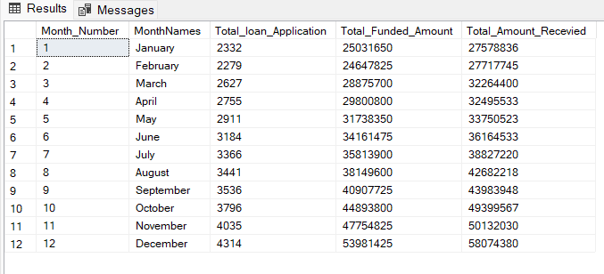

**2.Regional Analysis by state**

SELECT

address_state,

COUNT(id) AS Total_Applications,

SUM(loan_amount) AS Total_Funded_Amount,

SUM(total_payment) AS Total_Amount_Recevied

FROM bank_loan_data

GROUP BY address_state

ORDER BY Total_Funded_Amount DESC ;

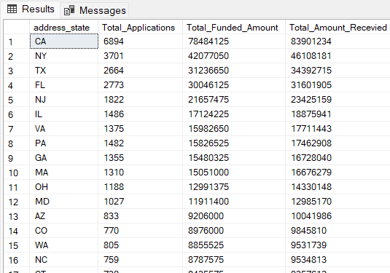

**3.Loan Terms Analysis**

SELECT

emp_length,

COUNT(id) AS Total_Applications,

SUM(loan_amount) AS Total_Funded_Amount,

SUM(total_payment) AS Total_Recevied_Amount

FROM bank_loan_data

GROUP BY emp_length

ORDER BY COUNT(id);

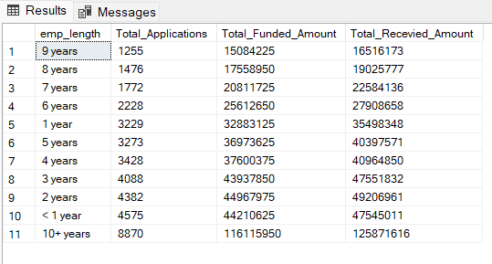

**4.Loan Purpose Breakdown**

SELECT

purpose,

COUNT(id) AS Total_Applications,

SUM(loan_amount) AS Total_Funded_Amount,

SUM(total_payment) AS Total_Recevied_Amount

FROM bank_loan_data

GROUP BY purpose

ORDER BY COUNT(id) DESC;

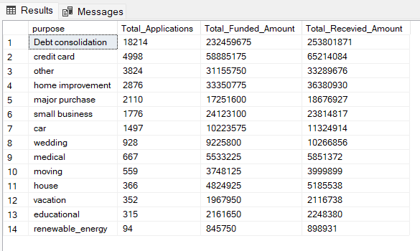

**5 Home Ownership Analysis**

SELECT

home_ownership,

COUNT(id) AS Total_Applications,

SUM(loan_amount) AS Total_Funded_Amount,

SUM(total_payment) AS Total_Recevied_Amount

FROM bank_loan_data

GROUP BY home_ownership

ORDER BY COUNT(id) DESC;

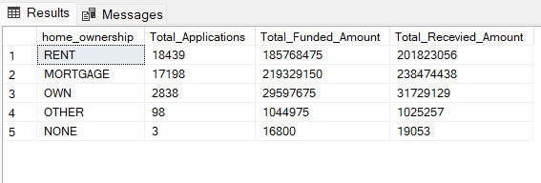

**DESHBOARD 3 : DETAILS**

SELECT * FROM bank_loan_data;

